1.https://e.vnexpress.net/news/news/education/uk-to-hike-proof-of-funds-requirement-for-international-students-from-nov-30-5139725.html

UK to hike proof-of-funds requirement for international students from Nov 30
By Minh Nga November 3, 2026 | 11:04 am GMT+7
Get VnExpress first in Google Search
The U.K. will increase the minimum maintenance funds international students must demonstrate for visa applications starting Nov. 30, with the maximum requirement rising by £369 (US$493).
Under updated Home Office immigration rules, the monthly maintenance requirement will rise from £1,529 to £1,570 for students studying in London. For those attending universities outside the capital, the requirement will increase from £1,171 to £1,203.
Students must prove they have sufficient funds for each month of their course, capped at nine months. This means applicants taking courses lasting nine months or longer will have to show £14,130 for living expenses in London, up from £13,761. Those studying outside London will need to show £10,827, compared with £10,539 previously.
The new financial thresholds apply based on the date an applicant submits their visa application, rather than the course start date. Applications submitted before Nov. 30 will be assessed under the existing rules.
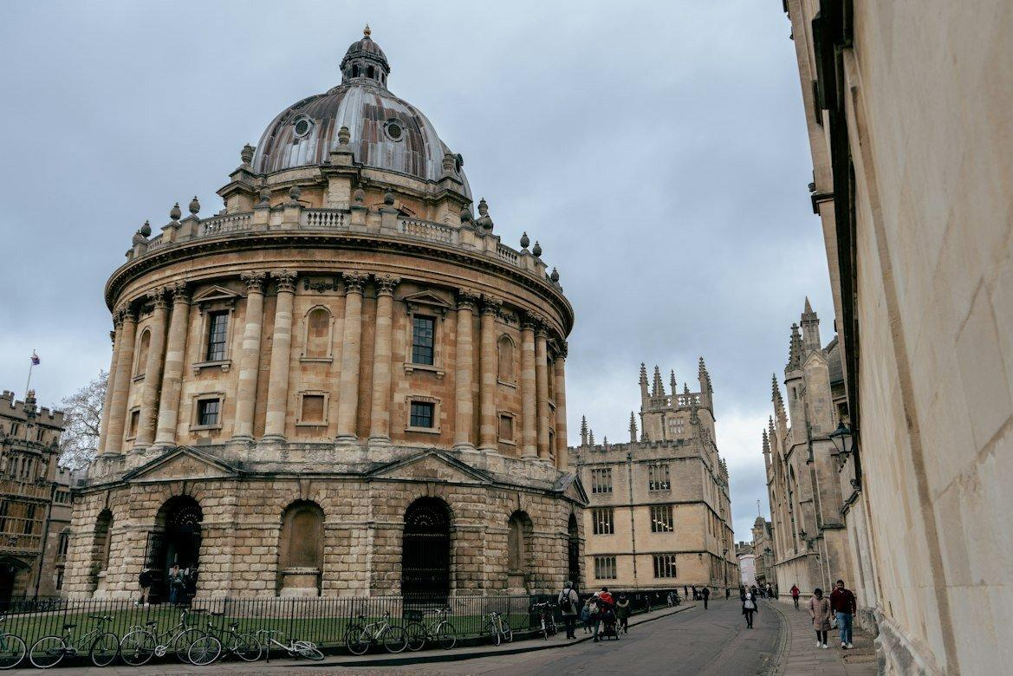
Oxford University in the U.K. Photo by Unsplash/Ben Elliott
This financial requirement is strictly for living costs and remains separate from tuition fees. Applicants must additionally demonstrate sufficient funds to cover any outstanding course fees for one academic year, as outlined in their Confirmation of Acceptance for Studies.
The Home Office links the maintenance requirement to the living-cost support available to domestic students through maintenance loans. This annual adjustment brings the figures in line with loan amounts for the 2026/27 academic year.
Students who have already paid for university accommodation can deduct that amount from their maintenance requirement. The maximum allowable deduction will also increase from £1,529 to £1,570.
Applicants must hold the required funds in an eligible bank account for at least 28 consecutive days. The final day of this 28-day period must fall within 31 days of the visa application date. For instance, an applicant applying on Jan. 1 must show the funds were held for 28 consecutive days ending no earlier than Dec. 1.
The requirement can also be met through qualifying student loans or official financial sponsorship.
Certain applicants are exempt from the financial requirement. This includes individuals applying as student union sabbatical officers and students who have lived in the U.K. on a valid visa for at least 12 months immediately preceding their application.
Students do not need to provide proof of funds if they are British nationals (overseas) or citizens of specific exempt countries and territories.
The exempt list includes Australia, Austria, Bahrain, Barbados, Belgium, Botswana, Brazil, Brunei, Bulgaria, Cambodia, Canada, Chile, China, Croatia, the Republic of Cyprus, Czechia, Denmark, the Dominican Republic, Estonia, Finland, France, Germany, Greece, Hong Kong, Hungary, Iceland, Indonesia, Ireland, Italy, Japan, Kazakhstan, Kuwait, Latvia, Liechtenstein, Lithuania, Luxembourg, Macao, Malaysia, Malta, Mauritius, Mexico, the Netherlands, New Zealand, Norway, Oman, Peru, Poland, Portugal, Qatar, Romania, Serbia, Singapore, Slovakia, Slovenia, South Korea, Spain, Sweden, Switzerland, Taiwan, Thailand, Tunisia, the United Arab Emirates, and the United States.
During the 2024/25 academic year, 685,565 international students were enrolled at U.K. higher education institutions, making up 24% of the total student population. Of these, 63,600 came from the EU and 622,000 from outside the bloc.
This total marks a 10% drop from the record high in 2022/23, representing the second consecutive year of decline. Since the current higher education sector was established in the early 1990s, international student numbers have fallen in only one other year, which was 2012/13.

2. Cost of living crisis: inspiring responses that empower communities https://www.positive.news/society/cost-of-living-crisis-refreshing-responses/
The UK cost of living crisis has meant more people relying on food banks and donated goods to get by. But how does this impact people’s sense of dignity? Two projects offer a novel take on what it means to give and receive
Before Carole Jones opened her ‘social supermarket’ in Dorset in November 2020, she had no idea it would grow to support hundreds of people.
When the pandemic first struck, Jones (main picture, above) recruited more than 100 volunteers to offer others assistance: from collecting prescriptions and shopping, to dog walking and more. After receiving some funding through her local clinical commissioning group, they began offering food vouchers too, and the Vale Pantry was born.
“The medical centre’s social prescribing arm discovered that 47 per cent of the surgery’s appointments were for people who didn’t really need to see a GP,” Jones says. “The reasons came down to isolation, anxiety and other factors, but also things like poor diet and food poverty. So, they were very keen to be involved in the setting up of the pantry.”
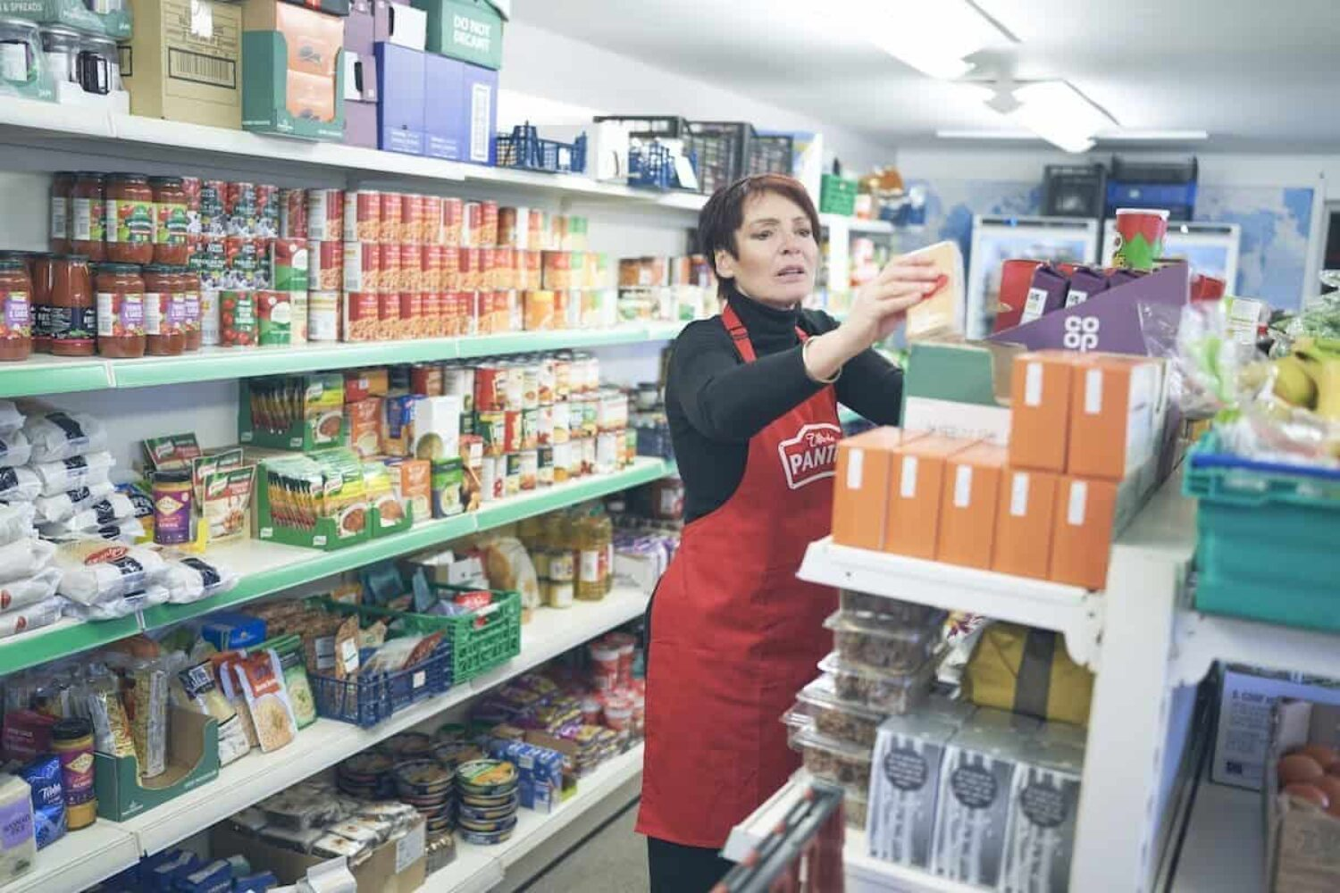
Vale Pantry members pay £6 a week for the equivalent of up to £60 worth of shopping. Image: Gareth Iwan Jones
Food insecurity is growing in the UK. In 2019-2020, 8 per cent of the population was living in food poverty (5 million people), according to the government’s Family Resources Survey. As of February this year, this figure stood at nearly 9 per cent, and may be even higher now, as families grapple with the cost of living crisis.
At the Vale Pantry, based in the town of Sturminster Newton, members pay £6 a week for the equivalent of up to £60 worth of shopping. Crucially, they are able to choose their own fresh fruit and vegetables, meat and fish, and everyday staples. Nappies, formula milk and sanitary wear are available for those who need them. More than 870 people, including 366 children, are now supported by the service – numbers that are “rising daily”, says Jones. As well as member contributions, funding comes from a patchwork of grants and other donations.
Jones felt that choice was all-important. “With the food bank model, you’re given a box and it’s normally just tins and packets,” she says. “When members come to us, they can go around and choose exactly what they want.”
When we first opened, it was almost as though people felt embarrassed. Now the pantry is a place full of fun and laughter
Jones and her team also help people to budget and put together recipe bags with instructions, to support members in cooking meals from scratch. “That’s been brilliant,” she enthuses. “People now are not afraid to take a butternut squash, a swede or a melon home.” She says they have also recently acquired some funding to purchase a number of slow cookers, which are distributed alongside a weekly bag of ingredients. “This has been done with the aim of reducing energy costs,” says Jones, adding that the last few months has seen the Vale Pantry busier than ever.
Preserving the dignity of those in financial uncertainty is also something that drives CJ Bowry, who lives in Surrey. She founded Sal’s Shoes in 2013 and has since distributed almost 4m pairs of secondhand shoes to children in 58 countries. The charity’s UK work has expanded significantly over the past two years, particularly through its school shoes fund Toe to Toe, which saw 41,000 pairs being donated in 2021 alone.

CJ Bowry has helped distribute almost 3m pairs of shoes to children. Image: Paul Clifton Photography
“I had calls with headteachers from five primary schools yesterday,” Bowry says. “They had all spotted kids with the soles literally flapping off their shoes. Many people don’t realise that shoe poverty exists. But for lots of the families we work with, it comes down to: ‘Do we pay to have the heating on? Do we pay to feed our children? Or: Do they go to school with holes in their soles?’ We have an education system that’s free to access, but school uniform is mandatory. What do you do if you can’t afford it?”
Research from the University of York confirms that the cost of school uniforms was unmanageable for some low-income families as children returned to school post-lockdown.
Sal’s Shoes has recently been working with the Guinness Partnership, a housing association that manages more than 66,000 homes across England, to set up shoe banks in three communities. Their Crewe, Salford and Hackney shops are filled with preloved shoes organised by size and colour, and laid out like a normal shoe shop. There are school shoes, trainers, wellies and more. Children can have their feet measured and choose the shoes they like best, rather than simply being given a pair that fits.
“It’s really trying to make it as close to a real-life shopping experience as possible: the only difference is families don’t have to pay,” Bowry says.
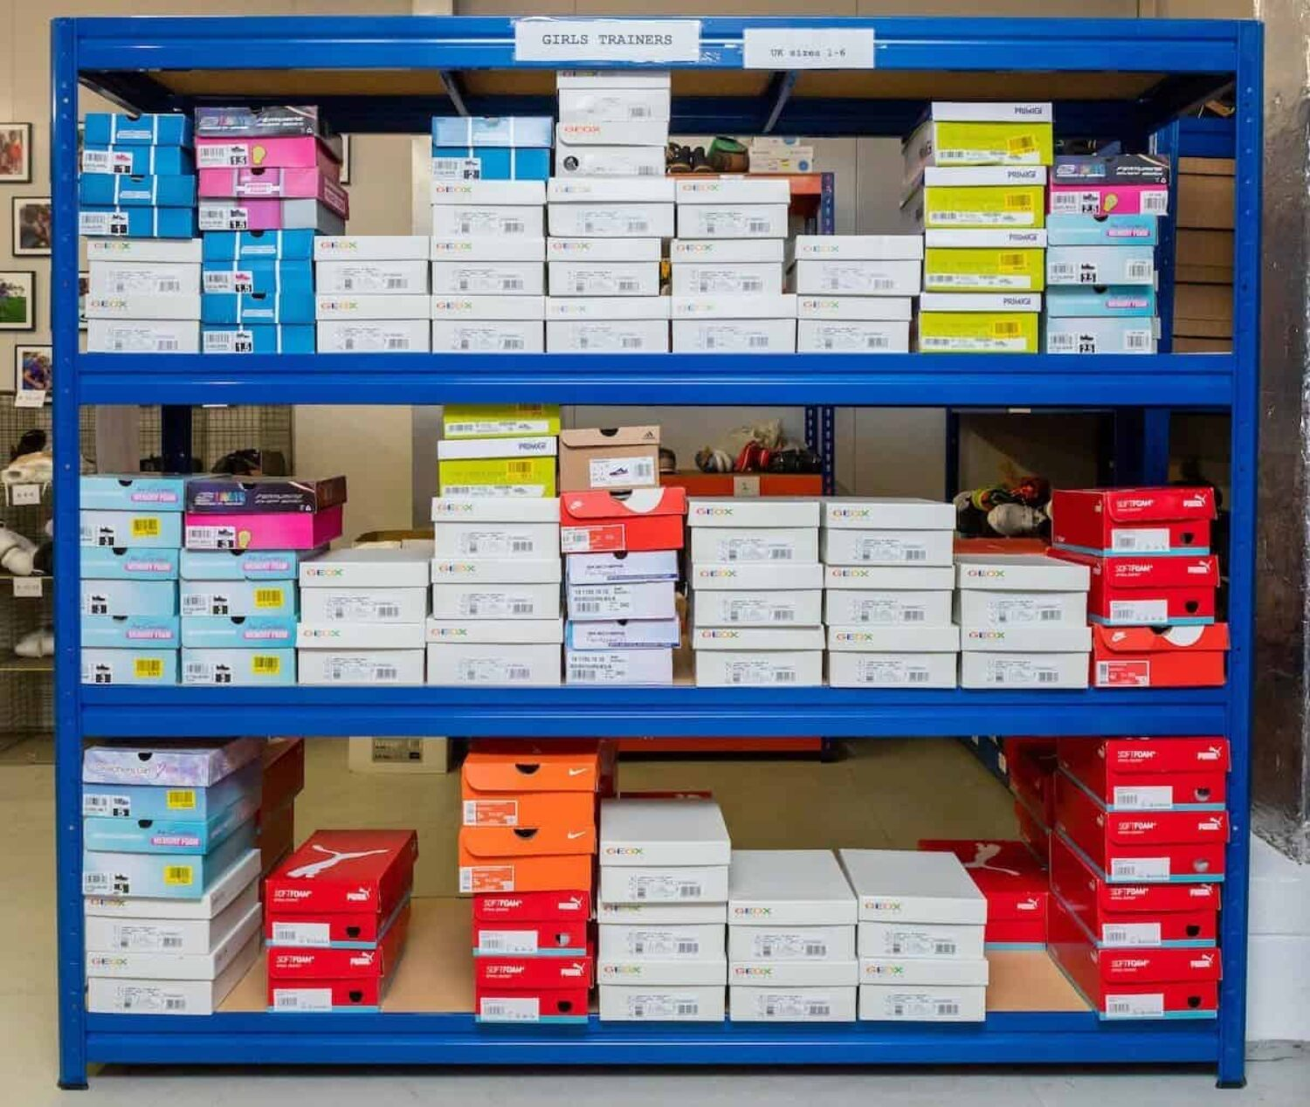
Children can choose the shoes they like best, rather than simply being given a pair. Image: Sal’s Shoes
The Guinness Partnership works with a range of charities, offering mentoring support, food pantry projects, clothing, bikes and more.
“We look at projects where people have choice,” says senior community partnership manager Brian Hamlin. “Everything we do in terms of alleviating hardship is about empowerment and improvement. It would be easy to put shoes in a box and say: ‘Your shoes are over there, go and get them.’ But to be able to pick a pair that you like? It’s hard to quantify the effects of that, not just on the child but [also] on the family.”
Sometimes people just need a stepping stone
Back in Dorset, Jones has just received an email from a member who suggests there should be a Vale Pantry in every UK town and village. She isn’t quite ready to take that on, but Jones is convinced that members now feel more dignified about accessing help to get back on their feet.
She knows first-hand that kindness in society goes a long way. “When we first opened, it was almost as though people felt embarrassed. Now the pantry is a place full of fun and laughter. For many, it’s their social outing of the week. Last year, we helped more than 190 families back to full independence, where they don’t need us any more. Sometimes people just need a stepping stone.”

3. https://en.nhandan.vn/lawmakers-propose-measures-to-boost-development-in-mountainous-border-regions-post168532.html

Lawmakers propose measures to boost development in mountainous, border regions
National Assembly (NA) deputies proposed measures to capitalise on regional strengths, strengthen connectivity and promote socio-economic development in midland, mountainous and border areas during discussions on the 2026 socio-economic development and state budget plans at the NA’s ongoing second session on October 31.
Saturday, October 31, 2026 at 18:26
NA deputy Doan Thi Le An from Cao Bang Province speaks at the discussion. (Photo: NDO)
They praised the Government, the Prime Minister and ministries, sectors and localities for their efforts, noting that despite numerous difficulties, Viet Nam has maintained high economic growth and basically stable macroeconomic conditions, creating a foundation for securing growth of at least 10% in 2027.
Improving livelihoods through forest protection
Deputy Ta Thi Yen from Dien Bien province highlighted the strategic importance of the northern midland and mountainous region in national defence, security safeguarding and upstream forest protection, while noting the hardships faced by local residents, particularly ethnic minority communities.
She said development policies should recognise their contributions and provide better livelihoods and incomes for people involved in forest protection.
While forest environmental service payments have delivered positive results, and the Government has introduced a policy on forest carbon absorption and storage services, she urged more effective implementation, assessment of real benefits for local communities and transparent management and use of revenues.
Such measures will improve living standards while protecting water resources and the ecological environment, she said.
Yen also pointed out that high transport costs, scattered production areas and shortages of cold storage facilities and logistics services are discouraging investment in agricultural processing and distribution.
She called for integrated transport infrastructure linking production areas with processing facilities, border gates and markets, alongside stronger incentives for businesses investing in agricultural processing, preservation and logistics in mountainous areas.
For the northern midland and mountainous region, it is necessary to continue capitalising on local advantages of agriculture, specialties, forestry, medicinal plants, processing industry, and tourism associated with natural landscapes and the cultural identity of ethnic minorities, the deputy added.
Preparing clean land for border-gate economic zones
Deputy Doan Thi Le An from Cao Bang province called for improved policies to develop the border-gate economy in mountainous and border areas, focusing on clean land preparation and investor selection.
She said international border gates such as Ta Lung and Tra Linh, together with the Dong Dang–Tra Linh expressway project, offer Cao Bang opportunities to expand trade with China and ASEAN. However, difficult terrain, limited land availability, high infrastructure costs and land and investment procedures remain major obstacles.
As suitable sites for logistics, warehousing and trade are often interspersed with agricultural, forestry and residential land, the preparation time for some projects can take 1.5–2 years while investors need ready-to-use premises, she noted.
An proposed that the Government consider submitting to the NA a pilot mechanism for preparing clean land in priority areas of border-gate economic zones, based on approved 1:2,000 zoning plans. She added that the mechanism should clearly define its scope, prioritise essential infrastructure, ensure adequate compensation and resettlement arrangements, and provide transparent oversight of land use and implementation.
She stressed that zoning plans must not replace legal requirements for land acquisition and that land preparation must protect residents’ livelihoods, particularly those of ethnic minority communities in border areas.
Regarding investor selection, the legislator suggested applying existing mechanisms under Articles 23 and 28 of the 2025 Investment Law while working out a mechanism to attract strategic investors to some logistics, warehousing and commercial projects with high spillover effects.
However, she cautioned against waiving land auctions and bidding procedures solely on the basis of registered investment capital of 500 billion VND (19.3 million USD) or more, saying this alone could not demonstrate an investor’s capacity or project effectiveness.
An called for clear selection criteria covering financial capacity, experience, disbursement commitments, job creation and contributions to local development, alongside transparent supervision and accountability.
4. Vietnamese Buddhist temples embrace TikTok sermons and QR code donations (Quỳnh)
https://vietnamnet.vn/en/vietnamese-buddhist-temples-embrace-tiktok-sermons-and-qr-code-donations-2570595.html
From sharing Buddhist teachings on TikTok to accepting donations via QR codes, temples in Vietnam's northern Quang Ninh province are embracing technology to connect with followers and modernize religious administration.
Buddhist teachings reach TikTok as temples adopt QR code donations
Buddhist teachings are no longer confined to sermons delivered within temple walls. Through social media, they are reaching wider audiences, allowing followers and members of the public to explore Buddhist philosophy wherever and whenever they choose.
Platforms such as Facebook and TikTok have become channels for sharing religious teachings, making Buddhism more accessible to people who may not have the opportunity to visit temples regularly.
At Van Phong Pagoda in Hoanh Bo Ward, Quang Ninh province, Venerable Thich Thanh Van, the temple's abbot, uses Facebook to post Buddhist teachings and TikTok to share videos of his sermons.
Social media not only broadens access to Buddhist teachings, particularly for those unable to attend temple activities in person, but also creates new ways for temples to maintain connections with their communities.
Bringing Buddhist teachings online, however, also raises questions about content quality. Sermons need to be presented in ways that are accessible and appropriate for digital audiences while remaining faithful to Buddhist doctrine. Care must also be taken to prevent edited or misleading content from distorting religious teachings.
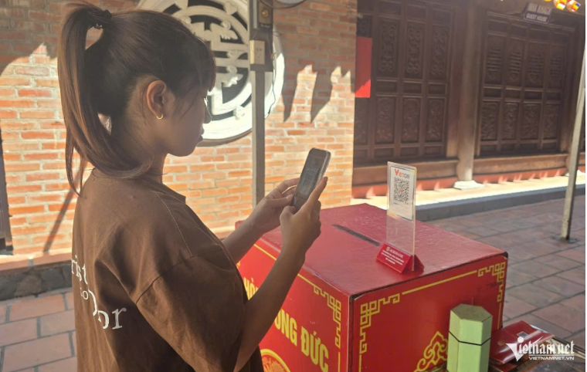
Visitors make religious donations by scanning QR codes at Long Tien Pagoda. Photo: My Dung
Technology is also changing everyday practices at places of worship, extending beyond the way Buddhist teachings are shared.
At Long Tien Pagoda, visitors can make voluntary religious donations by scanning a QR code and transferring money electronically. With a smartphone, worshippers can contribute without having to carry cash.
Pham Thi Thu, a resident of Viet Hung Ward, welcomed the convenience.
"Scanning a QR code gives me more flexibility because I no longer need to prepare cash in advance. Making a donation is still entirely voluntary. The QR code simply changes how we do it," she said.
Beyond facilitating payments, QR codes can also be used to provide information about a temple's history, architecture and cultural significance, allowing visitors and tourists to learn more about religious sites during their visits.
These developments show how digital technology is gradually becoming part of Buddhist life, offering greater convenience without changing the spiritual meaning of traditional practices.
Gradual digitalization of Buddhist administration
Alongside changes in religious outreach, digital transformation is creating new demands for the management and administration of Buddhist activities.
This has become particularly relevant following the restructuring of the Vietnam Buddhist Sangha, the country's national Buddhist organization, into a more streamlined structure effective July 1, 2025.
Quang Ninh currently has 625 monks and nuns, more than 150 Buddhist temples and monasteries, and approximately 200,000 Buddhist followers participating in 260 religious practice groups and associations.
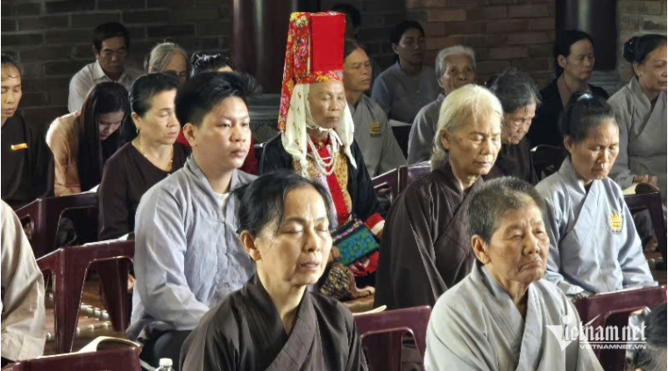
Quang Ninh currently has 625 monks and nuns, more than 150 Buddhist establishments and approximately 200,000 Buddhist followers. Photo: My Dung
With Buddhist establishments spread across urban areas, mountainous districts, border communities and islands, maintaining up-to-date information and coordinating activities requires increasingly flexible management methods.
Following the streamlining of intermediate administrative bodies, management boards at individual Buddhist establishments have assumed more direct responsibility for organizing temple activities.
This has increased the need to adopt digital tools, reduce reliance on paper records and improve administrative efficiency.
Efforts to develop a unified database covering Buddhist monks, nuns, temples and monasteries are currently being studied, coordinated and proposed for gradual implementation.
If introduced in a coordinated manner, such a system could help maintain updated records of monks and nuns, manage personnel information, compile data on annual monastic retreats and track other Buddhist activities.
The aim would be to make administration more convenient, accurate and efficient.
According to Venerable Thich Bao Minh, a member of the Executive Board of the Vietnam Buddhist Sangha in Quang Ninh province, digital transformation must address three interconnected areas: people, data and operational processes.
Simply investing in equipment and software, he said, would not be enough.
Monks and nuns need digital skills suited to their administrative responsibilities, while younger members of the monastic community could play an important role in helping temples adopt new technologies.
Despite the benefits, digitalization also brings challenges that require careful attention, including data security, transparency in financial transactions and support for people who are unfamiliar with smartphones and other digital devices.
From online Buddhist sermons and QR code donations to plans for digital management of monastic personnel and religious establishments, Buddhism in Quang Ninh is gradually adapting to an increasingly digital society.
The transformation is not merely about making religious activities more convenient. It also offers opportunities to strengthen ties with communities and bring Buddhist cultural and ethical values to a wider audience in modern life.
My Dung
5. Vietnam's GDP grows 9.01%, nearly triple global forecast (Quỳnh)
https://vietnamnet.vn/en/vietnam-s-gdp-grows-9-01-nearly-triple-global-forecast-2563213.html
VN's economy expanded 9.01% in the first 9 months of 2026, far outpacing the 2.9% global growth forecast for the year. Reaching its full-year target of at least 10% will require a strong final quarter, with public investment playing a crucial role.
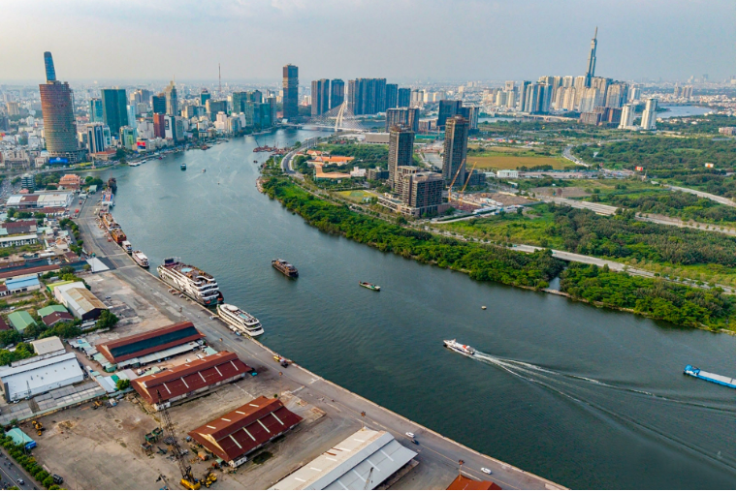
Vietnam's ambition to achieve GDP growth of at least 10% in 2026 sets a demanding target for the final quarter. Photo: Le Anh Dung.
GDP accelerates as public investment enters decisive phase
Vietnam is entering the final quarter of 2026 with strong economic momentum, supported by accelerating growth and encouraging indicators across several key sectors.
Gross domestic product (GDP) expanded 9.95% year-on-year in the third quarter, lifting growth for the first nine months to 9.01%, the highest rate recorded for the corresponding period since 2011.
The performance stands in sharp contrast to the global economic outlook, with worldwide GDP growth projected at just 2.9% for 2026.
Other major economic indicators also point to the country's resilience.
Industrial production increased by more than 12% during the January-September period, while total import-export turnover reached $888 billion.
Registered foreign direct investment (FDI) approached $50.4 billion, and disbursed FDI exceeded $21 billion.
Meanwhile, state budget revenue reached approximately $84.7 billion (VND2.19 quadrillion), equivalent to nearly 90% of the annual target.
Despite these encouraging results, achieving the Government's full-year growth target of at least 10% remains a formidable challenge.
Vietnam's GDP would need to expand by more than 12% in the fourth quarter, requiring a substantial acceleration in the country's main growth drivers.
Against this backdrop, public investment has emerged as one of the most important engines for maintaining economic momentum.
The Government has instructed ministries, agencies and local authorities to make full use of available growth opportunities while working toward disbursing 100% of the annual public investment budget.
By the end of September, public investment disbursement had reached nearly $24.9 billion (VND643 trillion), equivalent to approximately 63% of the allocation assigned by the Prime Minister.
That leaves a considerable amount of funding to be disbursed during the remaining months of the year.
In many localities, the pressure to accelerate disbursement is being passed down to individual agencies, with responsibility increasingly tied to their leaders.
Quang Tri Province, for example, has established specific milestones for October.
The province aims to disburse at least 55% of its allocated capital by October 15 and 65% by October 30.
Projects financed by funds carried over from 2025 to 2026 are required to complete 100% of their disbursement, except in cases of force majeure.
If public investment disbursement accelerates in the fourth quarter, the benefits could extend well beyond the infrastructure projects themselves.
Spending on roads, airports and other infrastructure can generate broader economic activity in construction, steel, cement, transportation, logistics, real estate, tourism and other service industries.
This is why Vietnam's ambition to achieve double-digit GDP growth carries significance beyond the headline figure.
Success would provide greater scope for expanding the country's economic scale and advancing its long-term ambition of joining the world's 30 largest economies.
Which stocks could benefit from faster public investment?
In Vietnam's stock market, the benefits of increased public investment generally spread across sectors in stages rather than appearing simultaneously.
Construction contractors and building-material producers are typically among the first to benefit, followed by logistics companies, property developers and related service businesses.
Transport infrastructure is at the center of the new investment cycle.
Major projects include the North-South Expressway, regional ring roads, Long Thanh International Airport, the North-South high-speed railway, the Hanoi-Quang Ninh metro project and urban metro networks.
Among building-material producers, Hoa Phat Group (HPG) stands out because of its large steel manufacturing capacity and its ability to supply major infrastructure projects.
Faster infrastructure development could generate additional demand for construction steel and other steel products used in large-scale projects.
Recent stock market movements suggest investors are again paying attention to the steel sector.
During the October 5 trading session, HPG shares rose 2.24% to approximately $0.79 (VND20,500) per share.
Several other steel-related stocks, including TLH, VCA, TIS, TVN, NKG and VGS, also recorded gains.
In the real estate sector, the impact of public investment is largely indirect.
Rather than benefiting directly from government spending, property developers stand to gain from improved transport connections and potential increases in land values around new infrastructure.
Vingroup (VIC) and Vinhomes (VHM) are particularly noteworthy because their business ecosystems span several areas related to urban development and infrastructure.
The completion of ring roads, metro systems and other transport links could enhance the value of large-scale residential developments built around improved connectivity.
For Vinhomes, better transport infrastructure could support property sales and strengthen real estate values in major urban projects.
Vingroup, meanwhile, could benefit from the expansion of infrastructure development and growing demand for large-scale investment.
Tourism represents another potential beneficiary of improved infrastructure.
Better road and air transport connections can shorten travel times, make destinations easier to reach and create opportunities to attract more visitors.
Accelerating public investment disbursement in the final quarter, while maintaining construction quality and ensuring efficient use of funds, could also generate additional employment, stimulate production and encourage private investment.
Together with domestic consumption, exports and other growth drivers, public investment is expected to play a significant role in helping Vietnam pursue its double-digit economic growth target for 2026.
Beyond the immediate boost to GDP, effective infrastructure spending could strengthen the country's economic foundations and improve its capacity for growth in the years ahead.
Manh Ha

6. A Vietnamese voice in a South African home https://vietnamnews.vn/society/1803581/a-vietnamese-voice-in-a-south-african-home.html
For overseas Vietnamese families living in South Africa, the greatest barrier to passing on their culture is communication.
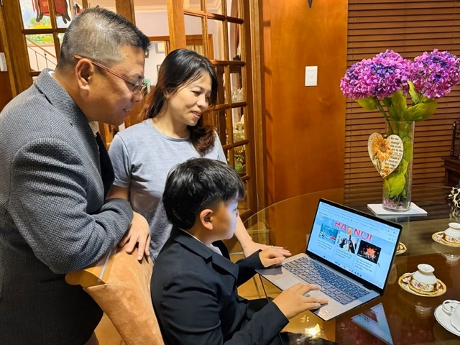
Vietnamese language and homeland history lessons are skilfully imparted by Lê Hoài Nam (left) to his son Tony through online platforms, guided by the belief that ‘keeping the soul of the homeland alive must begin within each household.’ — VNA/VNS Photo Đặng Huyền
HÀ NỘI — For Vietnamese people living abroad, keeping their language and culture alive begins at home.
That is the belief of Lê Hoài Nam, head of the Vietnamese Community Liaison Committee in South Africa.
For Vietnamese families in South Africa, language is the biggest barrier to passing on their culture, Nam said.
Children born and raised there mainly use English at school and with friends, while opportunities to speak Vietnamese are largely limited to the home.
That makes parents’ efforts all the more important.
“Our children may be born, grow up and study in South Africa, but what matters is that they understand they have Vietnamese roots. If parents do not make an effort to speak Vietnamese with them or help them learn about Việt Nam, it will be very difficult for them to develop a connection with their heritage as they grow up,” Nam said.
Drawing on his experience of teaching Vietnamese to his son Tony, Nam believes children learn best when they are encouraged rather than forced.
Instead of making Vietnamese feel like another school subject, his family made it part of Tony’s daily life through everyday conversations, stories about his grandparents and regular video calls to Việt Nam. These help him become more comfortable using the language.
“Whenever he manages to say a sentence in Vietnamese or learns something new about the culture, we always recognise his efforts and encourage him. When he joins community activities and meets other Vietnamese-speaking adults and children, he begins to understand that Vietnamese connects him not only to his family, but also to a much wider community,” Nam said.
Success does not necessarily mean children speaking Vietnamese as fluently as their peers in Việt Nam. What matters is that they remain connected to the language, understand their roots and feel proud to be Vietnamese.
Preserving cultural values
For Nam, passing on Vietnamese culture means more than teaching the language or introducing children to traditional clothes and food.
“These things certainly matter, but Vietnamese culture is also reflected in how we treat one another: the love we share within our families, respect and care for our parents and grandparents, and, above all, compassion and a willingness to help others,” he said.
“These shared values help Vietnamese people feel connected to one another, wherever they live in the world.”
In his years of community work, Nam has seen that solidarity in action when members help newcomers settle in or support families through difficult times.
Gathering for festivals and Tết, as well as helping one another through hardship, gives children born abroad a chance to experience that sense of community for themselves.
He also stressed that preserving Vietnamese identity should go hand in hand with integration.
“Preserving our identity does not mean closing ourselves off. We can participate fully in South African society and respect its laws while maintaining a strong sense of who we are as Vietnamese people.”
South Africa’s Vietnamese community is small and widely dispersed, with some members living hundreds or even thousands of kilometres apart.
Keeping people connected is therefore a constant challenge for the Liaison Committee.
Nam believes the community should find more opportunities to come together throughout the year, rather than waiting for major festivals or Tết. Combining gatherings with online activities would allow members to stay in touch, share information and help one another with legal matters and everyday difficulties.
Support from the Vietnamese Embassy and other Vietnamese representative offices is also important.
“We very much hope that agencies back home will offer more practical support, such as Vietnamese-language teaching materials designed for children born abroad or exchange programmes for young people,” Nam said.
“Here in South Africa, annual cultural events such as the Mid-Autumn Festival and the ‘Spring of the Homeland’ programme are especially important. Bringing these celebrations to communities from Pretoria to Cape Town helps people feel connected to their roots and gives them a sense of belonging.”
For Nam, a strong community depends on mutual respect, a willingness to listen and shared responsibility. Everyone, from successful entrepreneurs and experienced intellectuals to other community members, should feel valued and have a say. Only then can the community grow stronger, with more people contributing rather than leaving the work to a few dedicated individuals.
Intellectual capital
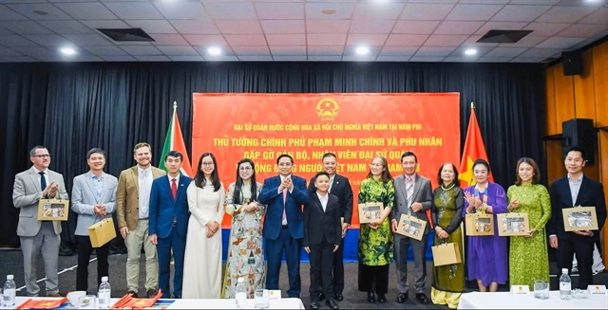
Former Prime Minister Phạm Minh Chính (centre) and his wife at a gathering with the Vietnamese community in South Africa. — VNA/VNS Photo
Nam sees the upcoming event marking Great National Unity Day on November 18 and Việt Nam Cultural Day on November 24 as an opportunity to bring people together.
He hopes its impact will last beyond a week of activities. To achieve that, young people should help shape and organise the programme themselves, whether by making videos about Việt Nam or inviting their South African friends to enjoy Vietnamese food, music and folk games.
Nam also believes greater recognition should be given to what overseas Vietnamese can contribute to the country’s development, from professional knowledge and management experience to scientific and technological expertise and international networks.
Vietnamese people who live and work responsibly in South Africa also help others gain a better understanding of Việt Nam.
To make better use of these skills and connections, agencies in Việt Nam need to create practical opportunities for overseas Vietnamese to contribute.
Understanding what both sides need is essential to turning ideas into concrete projects in education, trade and technology transfer.
Reflecting on his efforts to keep Vietnamese language and culture alive far from home, Nam said overseas Vietnamese remain deeply attached to their homeland, however far away they live.
He believes Vietnamese culture can continue to thrive in South Africa if families do their part to pass it on and agencies in Việt Nam provide practical support. For younger generations, that means being able to embrace life in South Africa while staying connected to their Vietnamese roots. — VNS

7. Vietnam for first-timers, beach lovers and nightlife seekers: Where to go? https://news.tuoitre.vn/vietnam-for-first-timers-beach-lovers-and-nightlife-seekers-where-to-go-103261022142743028.htm
From Hanoi’s historic streets and Ho Chi Minh City’s vibrant nightlife to Phu Quoc’s sandy beaches and Ha Giang’s spectacular mountain passes, Vietnam offers destinations for every kind of traveler, according to travel magazine Lonely Planet.
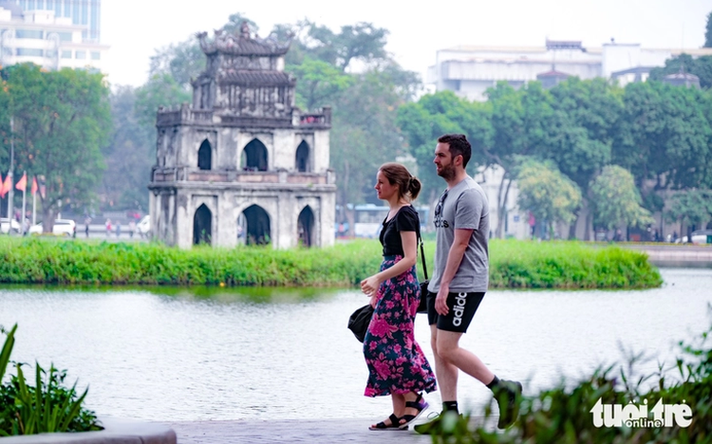
Foreign tourists pass Hoan Kiem Lake in Hanoi. Photo: Nam Tran / Tuoi Tre
Vietnam attracts travelers with its terraced rice fields, ancient historical sites, idyllic beaches and energetic cities. In a guide to the country’s top destinations, Lonely Planet highlights places suited to first-time visitors, adventure seekers, history enthusiasts and those looking for sun and nightlife.
The renowned magazine affirmed that Vietnam is a magnet for visitors in search of unforgettable travel memories.

Hanoi: Best for first-time visitors
Vietnam’s historic capital is an ideal starting point for first-time visitors, offering convenient infrastructure, affordable accommodation, diverse dining options and a wealth of historical attractions.
Hanoi also serves as a gateway to the limestone islands and outcrops of Ha Long Bay and the forested trails of the mountainous northwest.
Visitors can explore the city’s many attractions, sample Vietnamese street food and relax at cozy cafes in the Old Quarter.
For budget-friendly nightlife, Lonely Planet recommends the bia hoi (draft beer) stalls around Bia Hoi Junction on Ta Hien Street.

Phong Nha - Ke Bang National Park: Best for underground adventures

Son Doong Cave. Photo: Tuoi Tre
Home to Son Doong, the world’s largest cave by volume, Phong Nha - Ke Bang National Park in Quang Tri Province, north-central Vietnam, is a major draw for adventure travelers.
Access to Son Doong is strictly controlled, with expensive guided expeditions that must be booked months in advance.
However, the park contains numerous other caves that visitors can explore by climbing, crawling, boating or zip-lining at a fraction of the cost.
Phong Nha, Paradise and Tu Lan caves offer options for travelers on tighter budgets, while En Cave provides a more adventurous experience, with trekkers able to camp on an underground beach illuminated by natural light.

Hue: Best for imperial history
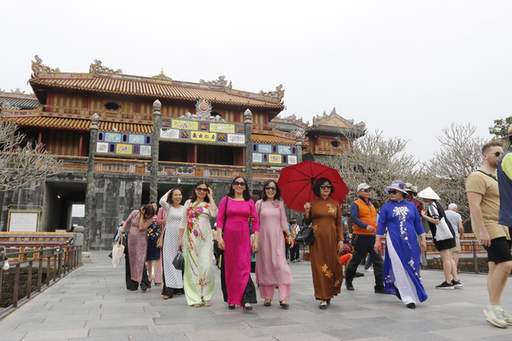
Tourists in ‘ao dai’ visit the Complex of Hue Monuments in Hue City. Photo: Nhat Linh / Tuoi Tre
The former capital of the Nguyen dynasty preserves much of Vietnam’s imperial heritage despite the destruction suffered during the war.
The Imperial Citadel and Imperial Enclosure feature the remains of royal residences, temples, palaces and court buildings. Outside the city, the tombs of former emperors sit amid green compounds along the Perfume River.
Hue’s royal culinary traditions are another highlight. Visitors can sample bun bo Hue, a spicy beef noodle soup, and banh khoai, a crispy pancake.
Lonely Planet recommends renting a motorcycle or scooter to explore the imperial tombs and stopping at Thien Mu Pagoda.

Lan Ha Bay and Bai Tu Long Bay: Best for less-crowded cruises
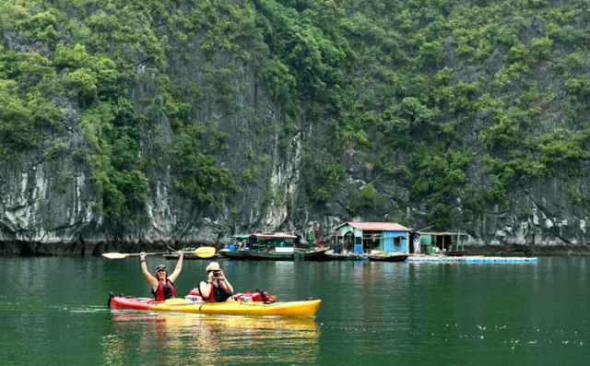
Tourists kayak in Lan Ha Bay. Photo: Duc Hung / Tuoi Tre
Travelers seeking quieter alternatives to Ha Long Bay can head to Lan Ha Bay in Hai Phong City or Bai Tu Long Bay in Quang Ninh City, both in the north, where limestone formations and islands create similarly spectacular scenery but generally attract fewer cruise boats.
Activities include kayaking among the karst outcrops and hiking through Cat Ba National Park on Cat Ba Island, the gateway to Lan Ha Bay.
Bai Tu Long Bay also offers beaches and seafood restaurants on Co To Island, making it an option for travelers looking to combine coastal scenery with a more relaxed atmosphere.

Phu Quoc: Best for beaches and family fun
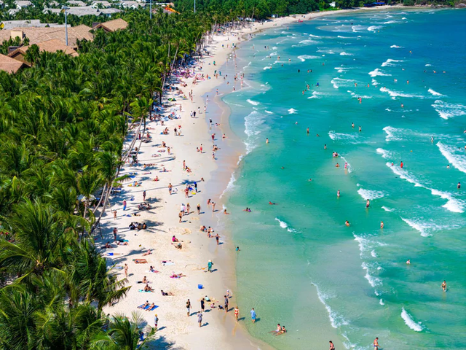
Kem Beach in Phu Quoc. Photo: Tuoi Tre
Located in the Gulf of Thailand, Phu Quoc in southern Vietnam is known for its blue waters, sandy beaches and laid-back atmosphere.
The island also caters to families, with attractions including VinWonders theme park and the overwater cable car at Sun World Hon Thom. Travelers looking for a break from the busy tourist areas can explore the island’s inland jungles.
Direct flights connect Phu Quoc with regional hubs including Bangkok, Kuala Lumpur and Seoul. Lonely Planet also notes that eligible visitors can stay on the island for up to 30 days without a visa under its separate visa-exemption policy.

Hoi An: Best for old-world charm
Quảng cáo
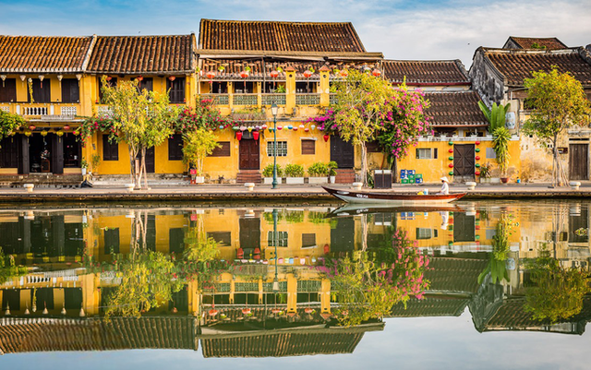
A view of Hoi An Ancient Town. Photo: Tuoi Tre
Hoi An in the central region offers a glimpse into Vietnam’s trading past. Once a major Asian port, the town attracted merchants from Japan, Spain and North America, whose influence can still be seen in its historic architecture.
Hoi An Ancient Town features traditional shophouses, former tea warehouses, covered bridges, Chinese-style assembly halls and colorful Confucian and Buddhist pagodas.
Beyond sightseeing, visitors can join cooking classes to learn how to make local dishes such as white-rose dumplings and summer rolls, or have suits and gowns tailored at the town’s shops.
For a different experience, travelers can head inland and spend a night at a community homestay in Bho Hoong, a Co Tu minority village.

Ha Giang: Best for mountain views

A peaceful rice field nestled amidst towering limestone mountains in Ha Giang. Photo: Nguyen Hien / Tuoi Tre
Ha Giang, now part of Tuyen Quang Province in northern Vietnam, offers remote mountain scenery, rural villages and winding roads through dramatic limestone peaks.
Travelers can hike to local communities, see rice terraces tucked between mountains and motor over some of Vietnam’s most spectacular passes to take photos on routes linking Ha Giang town with Dong Van and Meo Vac.
Those planning to ride a motorcycle or scooter should ensure they have the appropriate driving license. Alternatively, they can book a tour or hire a local guide to drive them through the region.

Ho Chi Minh City: Best for nightlife
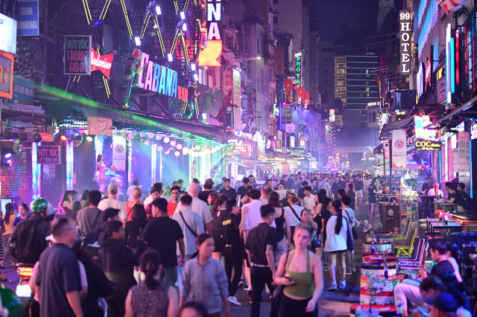
Crowds of international visitors fill Bui Vien Walking Street in downtown Ho Chi Minh City. Photo: Quang Dinh / Tuoi Tre
Ho Chi Minh City is fast-paced, frenetic and fun, particularly after dark, when the pavements transform into a mobile buffet of street food stalls and roadside bars.
The southern metropolis also offers a mix of cultural influences, historical landmarks and dining experiences. Visitors can learn about the country’s wartime history at the War Remnants Museum, explore colonial-era architecture and sample Vietnamese drip coffee at local cafes.
For a change of pace, travelers can take a trip to Tay Ninh Province to visit the Cao Dai Holy See, a major religious complex associated with the Cao Dai faith.

Central Vietnam’s beaches: Best for sunseekers
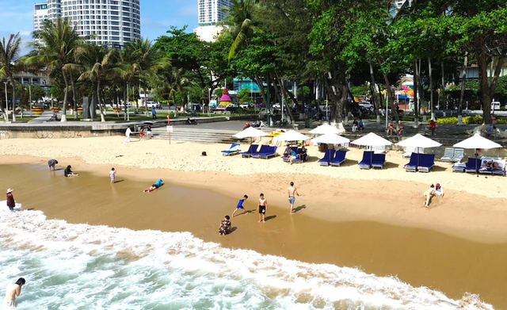
Nha Trang Beach. Photo: Nguyen Hoang / Tuoi Tre
Vietnam’s central coastline offers beaches with different atmospheres, from lively resort areas to quieter stretches of sand.
Da Nang and Nha Trang attract package tourists with their beach facilities and coastal attractions. Nha Trang also features Cham-era ruins, Buddhist shrines and seafood restaurants.
For a more relaxed seaside escape, Mui Ne is known for kitesurfing and sandy coves, while Doc Let Beach offers an 18-kilometer stretch of sand and opportunities to enjoy seafood.
Travelers seeking quieter beaches can also explore the coast between Hue and Da Nang, including Thuan An Beach.

Ba Be National Park: Best for lakes and forests
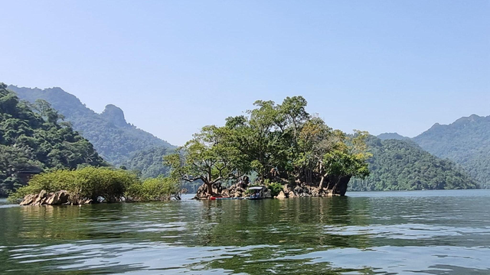
Ba Be Lake in Ba Be National Park in Thai Nguyen Province. Photo: Tuoi Tre
Ba Be National Park in Thai Nguyen Province, northern Vietnam, offers forested mountain scenery, tranquil lakes and trails leading to villages inhabited by Hmong, Tay and Dao communities.
Visitors can explore the area on foot or take boat and kayak trips across lakes surrounded by forest-covered limestone ridges.
The park is also home to wildlife including macaques, langur monkeys, black bears, pangolins and crested serpent eagles.
For travelers hoping to experience rural life away from the main tourist routes, family-run guesthouses in Pac Ngoi village provide homestay accommodation. The village can be reached by bus from Hanoi.

Inside Hanoi tycoon’s 100-year-old villa in the Old Quarter https://e.vnexpress.net/photo/trend/inside-hanoi-tycoons-100-year-old-villa-in-the-old-quarter-5140151.html
A century-old, 800-square-meter villa on Hang Be Street in Hanoi’s Hoan Kiem Ward has been preserved by descendants of its original owner.
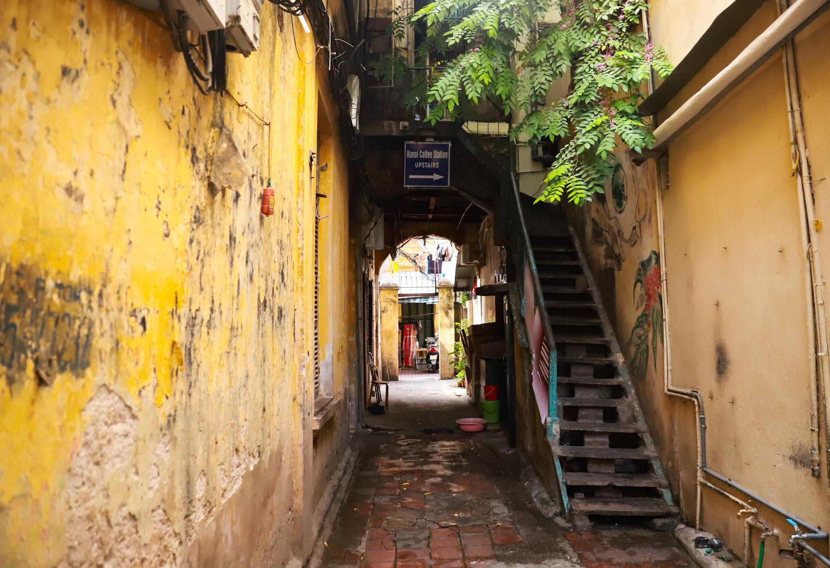
The villa was built in 1926 by Truong Trong Vong, a merchant who had hundreds of rickshaws for rent. It was designed by a French architect.
Today, it is looked after by Vong’s granddaughter, Le Thanh Thuy, 71. Its gate was built in the traditional Vietnamese “to vo” (wasp) style.
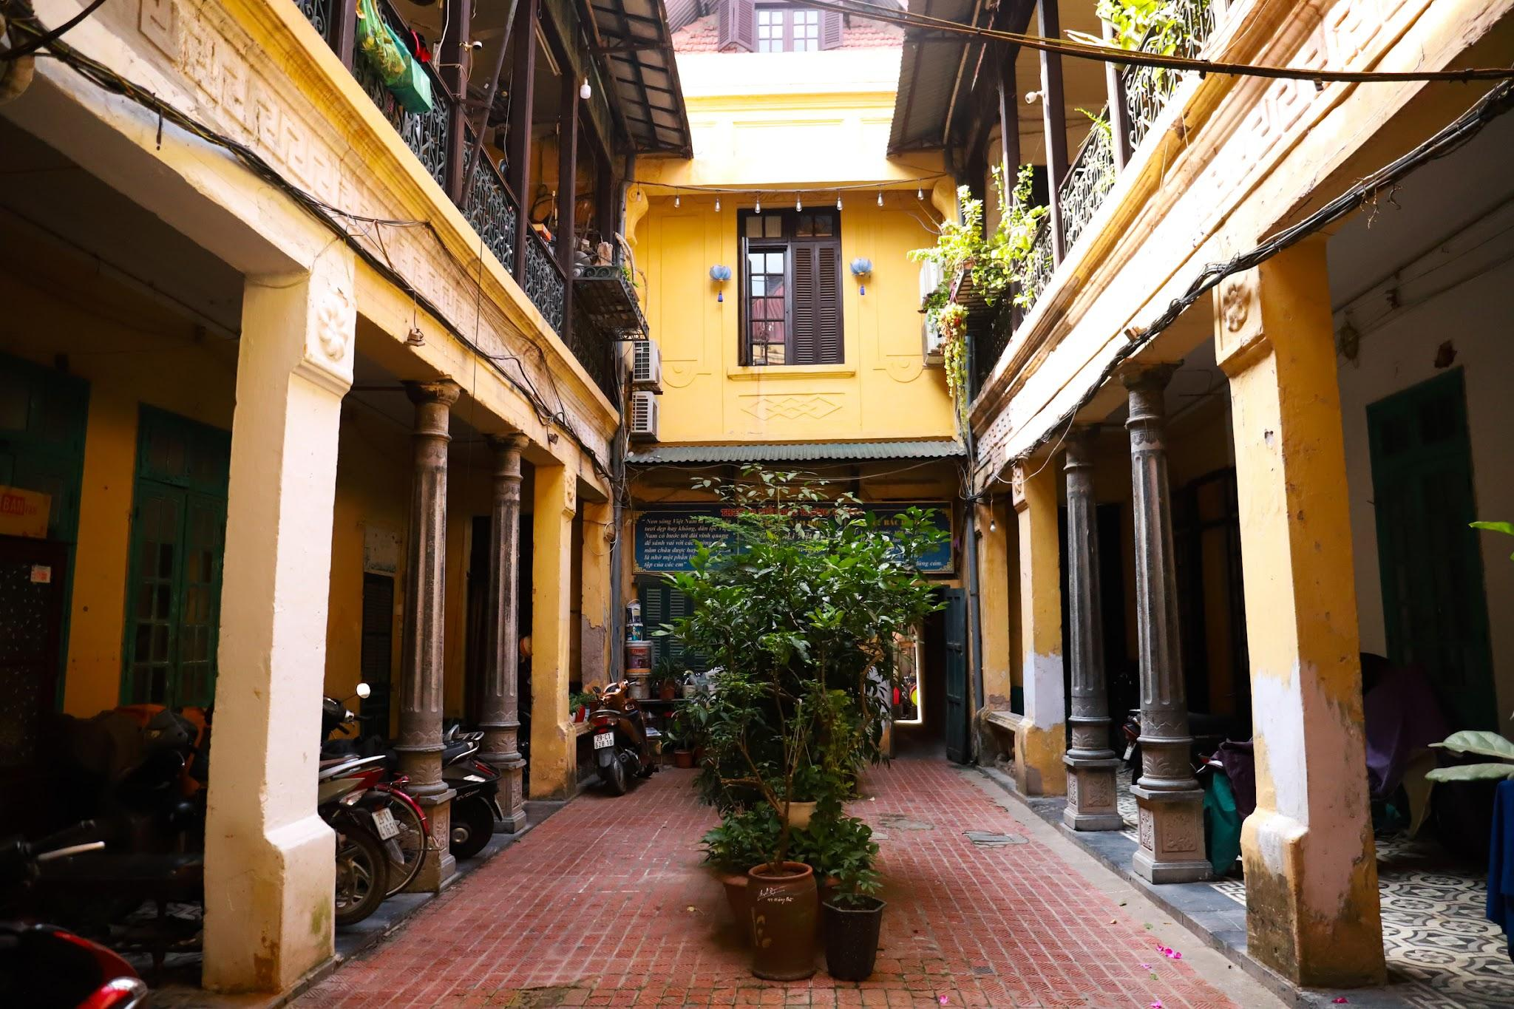
The villa was designed in the shape of the Chinese character for "Khẩu" (mouth), consisting of enclosed blocks that surround a central courtyard. This design ensures security while creating a skylight that allows all rooms to receive natural light.
According to HANOIDB (Hanoi Architectural Database under Kyoto University, Japan), the rows of cast-iron columns along the corridor around the courtyard and the wrought-iron staircase handrails on the upper floor are signature architectural features of the villa.
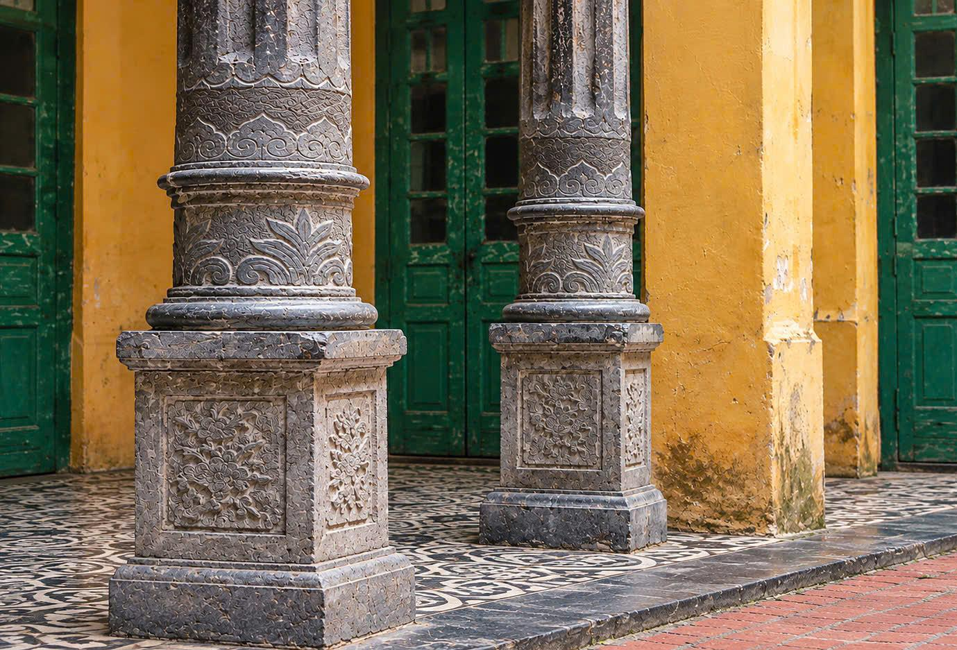
One of the villa’s architectural highlights is a set of four solid stone pillars, intricately carved with the traditional "Four Seasons" (peach - chrysanthemum - bamboo - apricot) motifs. The four plants symbolize the turning of the four seasons, carrying wishes for a year of harmony, favorable weather, peace, and good fortune.
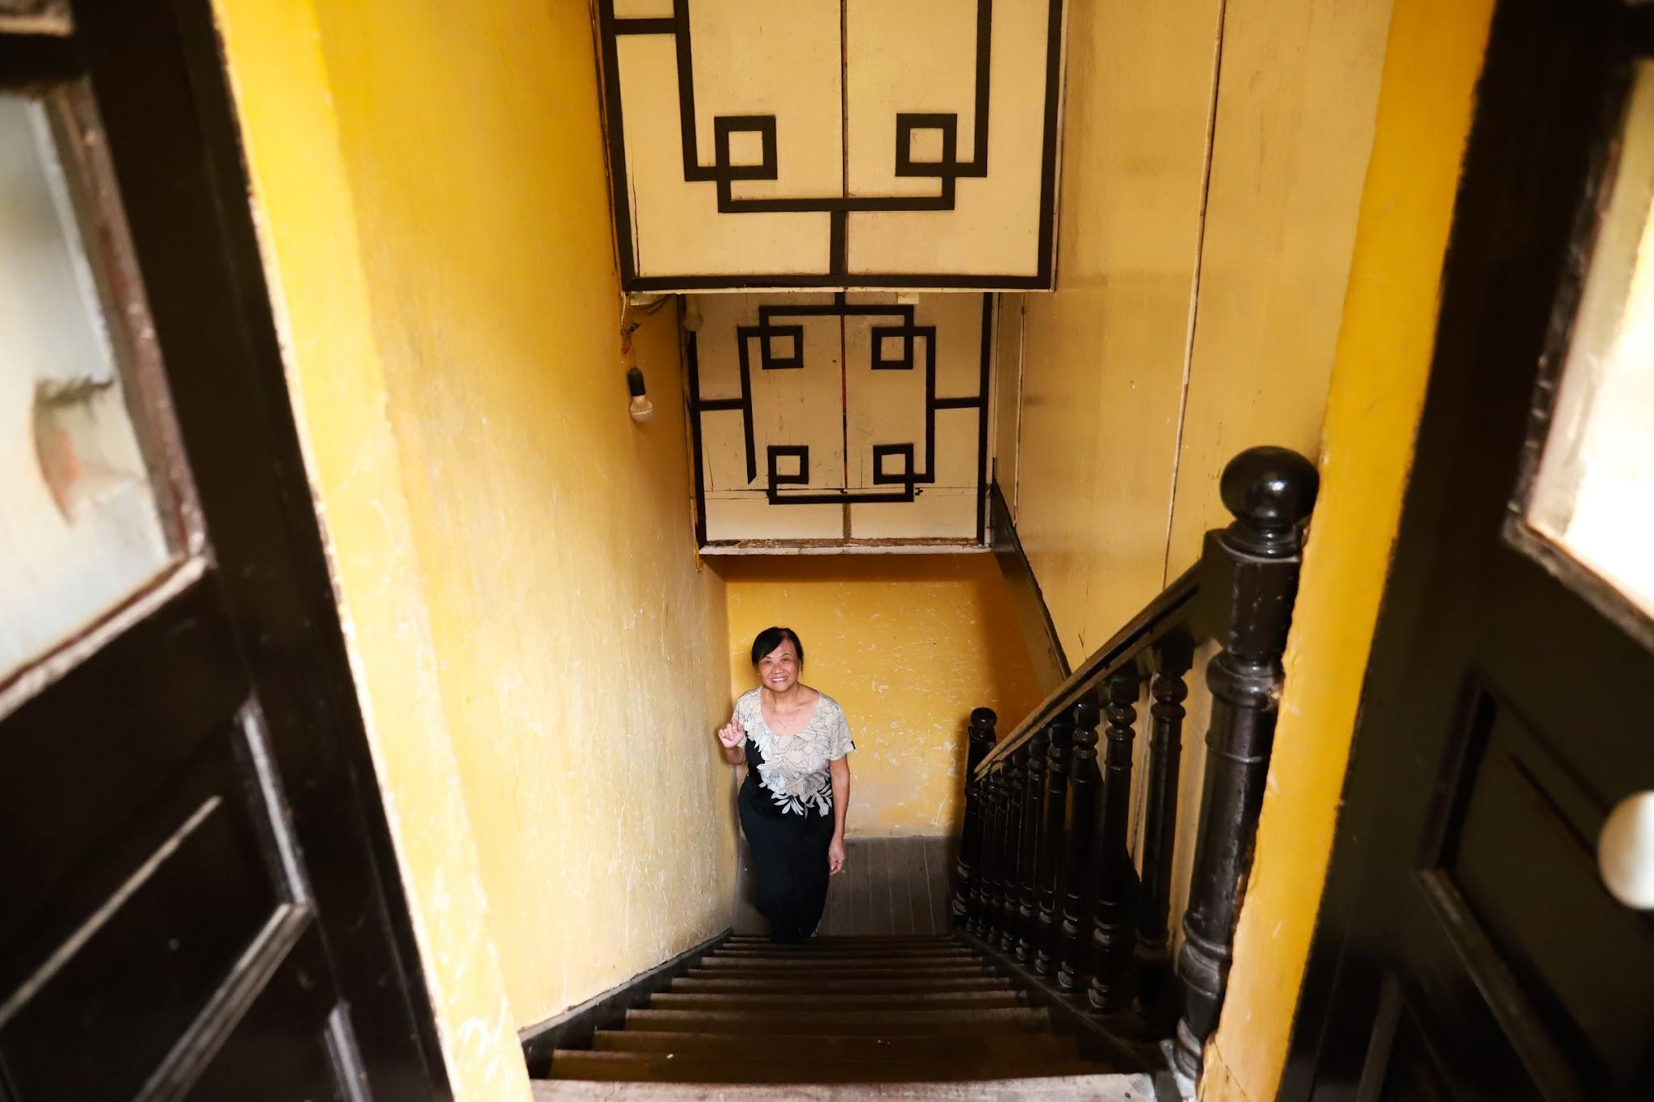
Thuy's family mainly live on the second floor.
The staircase leading from the first floor to the second is made of ironwood. The balustrade has rounded wooden balusters, and the top of the newel posts are in the shaped of a sphere.
Above the stairs, decorative panels with traditional East Asian architectural patterns serve as ventilation grills or partitions that let in light while also following the feng shui principle of expressing wishes for lasting prosperity and peace for the household.
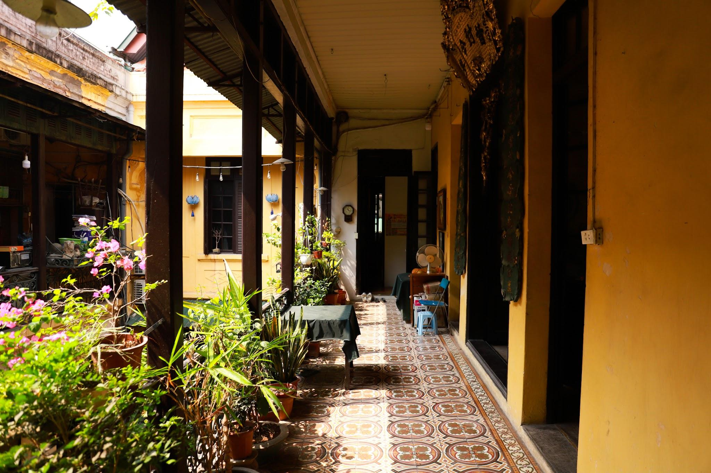
Despite being built 100 years ago, the villa has a remarkably modern design, including self-contained bedrooms for each family member, guest rooms, a dining room, and rooms for domestic workers.
“All the rooms are designed to connect with one another and form a united whole. The elders said that the design was meant to keep the family close, so that everyone would love and support each other,” Thuy says.
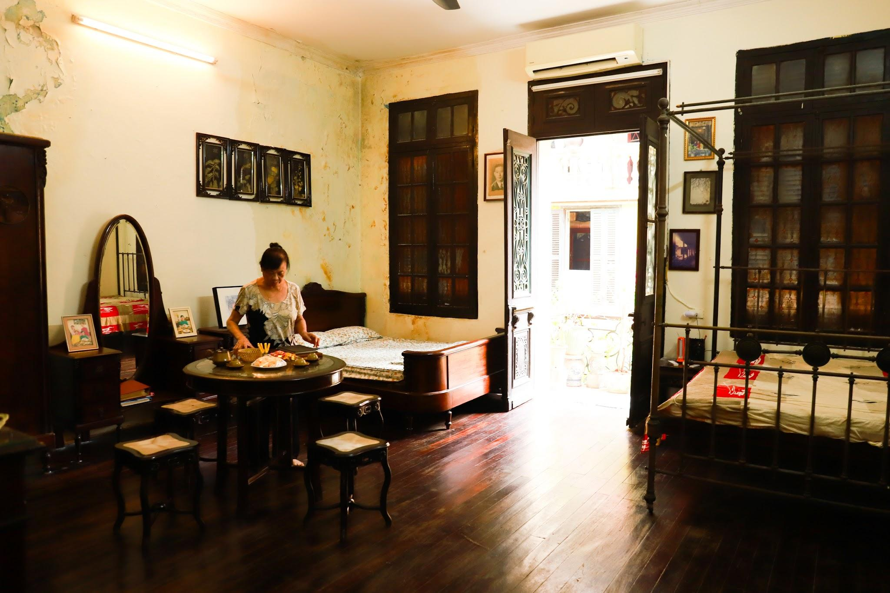
Much of the interior furniture, such as tables and chairs, wooden daybeds, cabinets, and beds, was imported from Europe or Hong Kong in the early 20th century and has been preserved to this day.
A century ago, the value of an imported set of tables, chairs, vanity table, and bed was equivalent to the cost of a small house, according to Thuy.
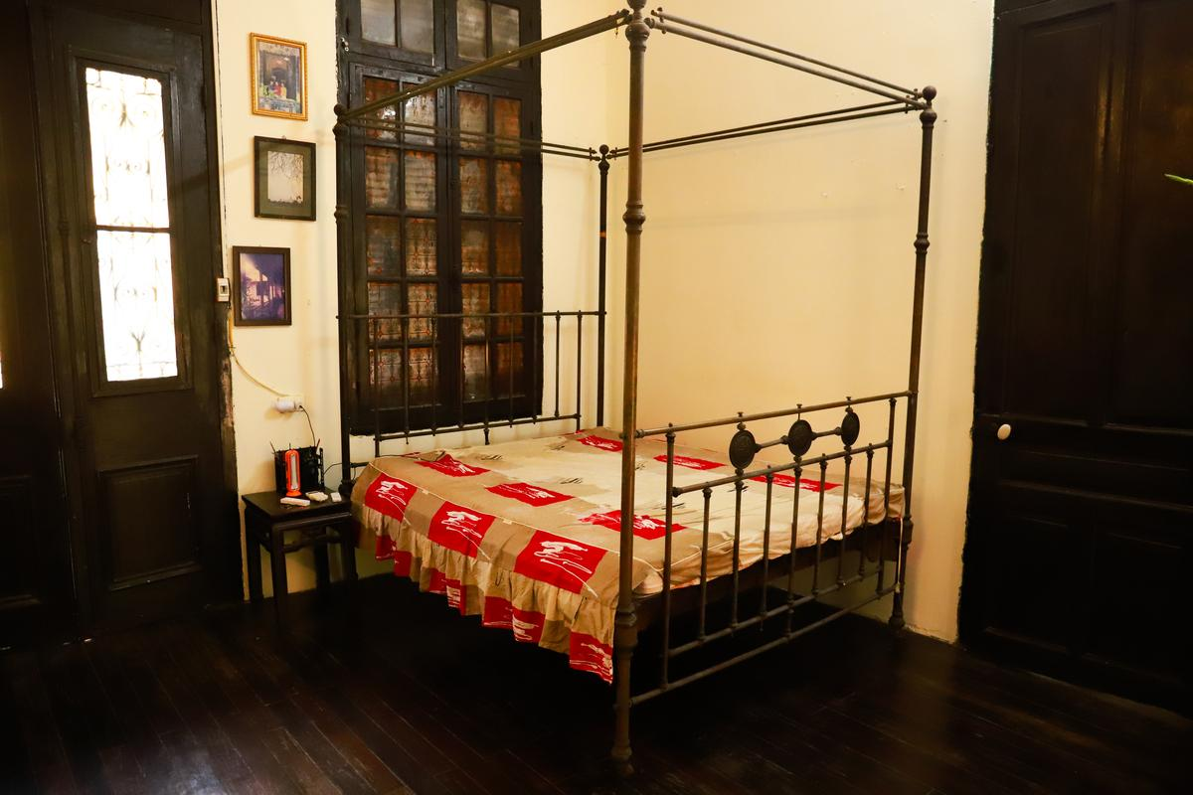

The brass bed was purchased by Vong in 1926.
"With all antique furniture, I only dust the surface and not polish it, as I want to preserve its vintage character," Thuy says.
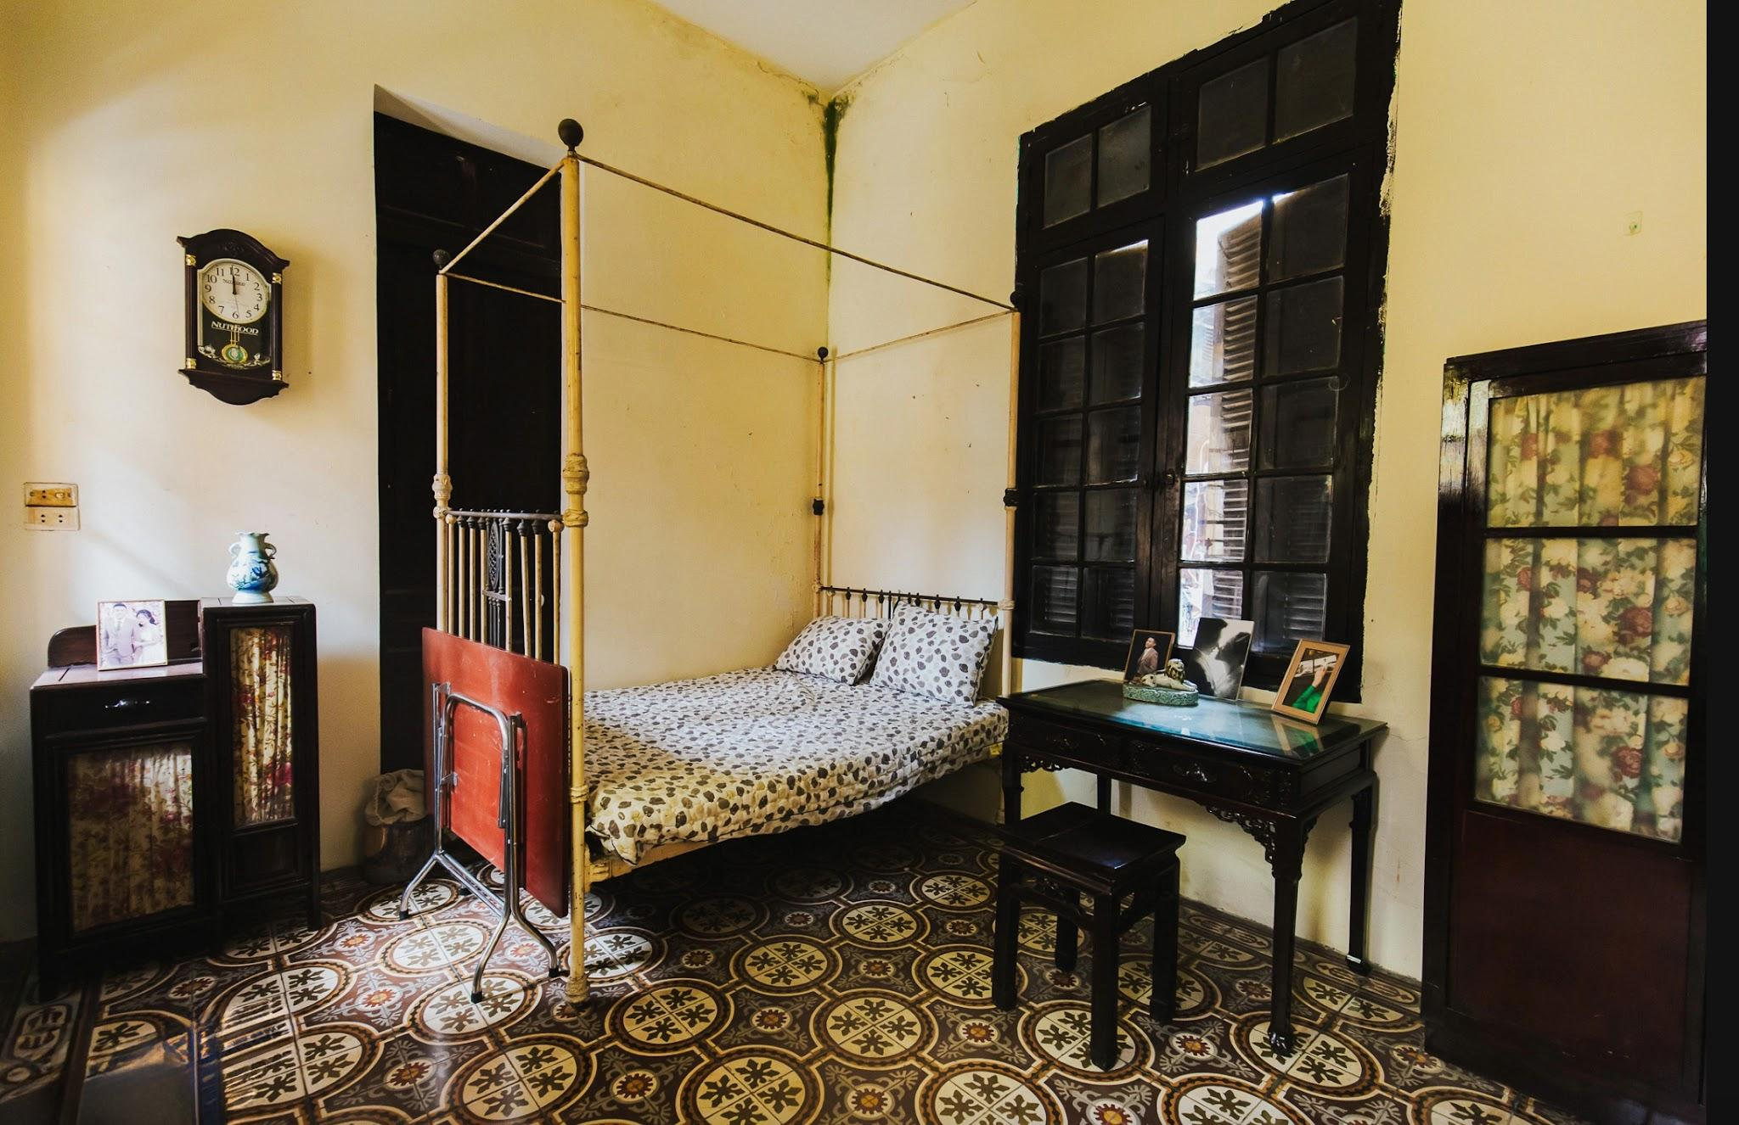
The villa served as a filming location for many films, such as “Mui Pho” (Scent of Pho), “Ha Noi Mua Dong Nam 46” (Hanoi: Winter of '46).
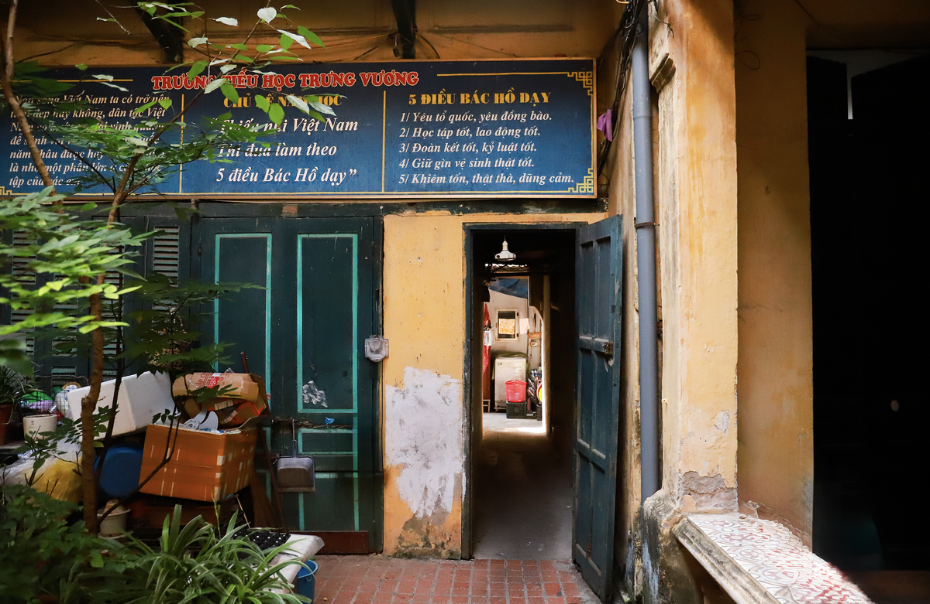
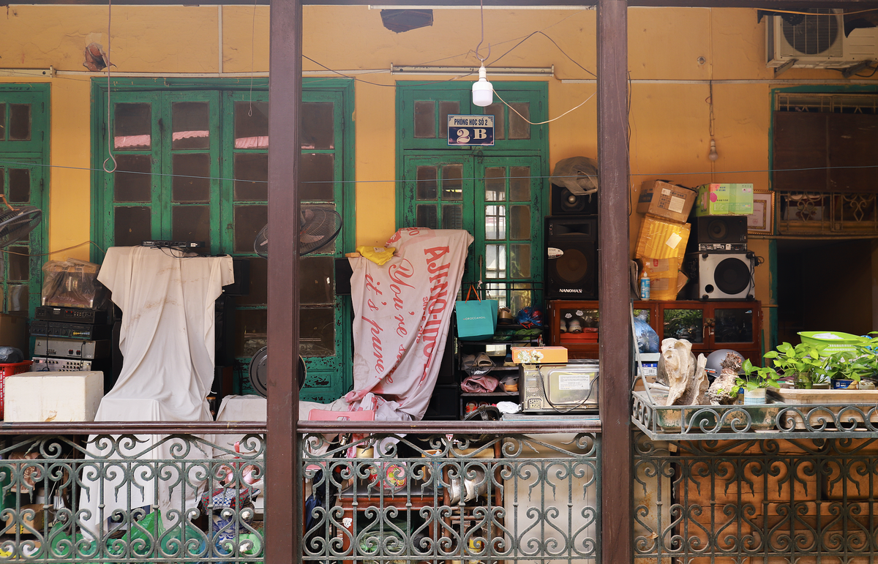
In 1960, Thuy's family donated a portion of the villa to the government to be converted into classrooms.
The outer section was assigned for residential housing, while the building on the left of the entrance gate became Bac Son Primary School. In 2018, the school relocated, but the old classroom space and some learning equipment still remain.
Currently, her family manages an area of just over 200 square meters.
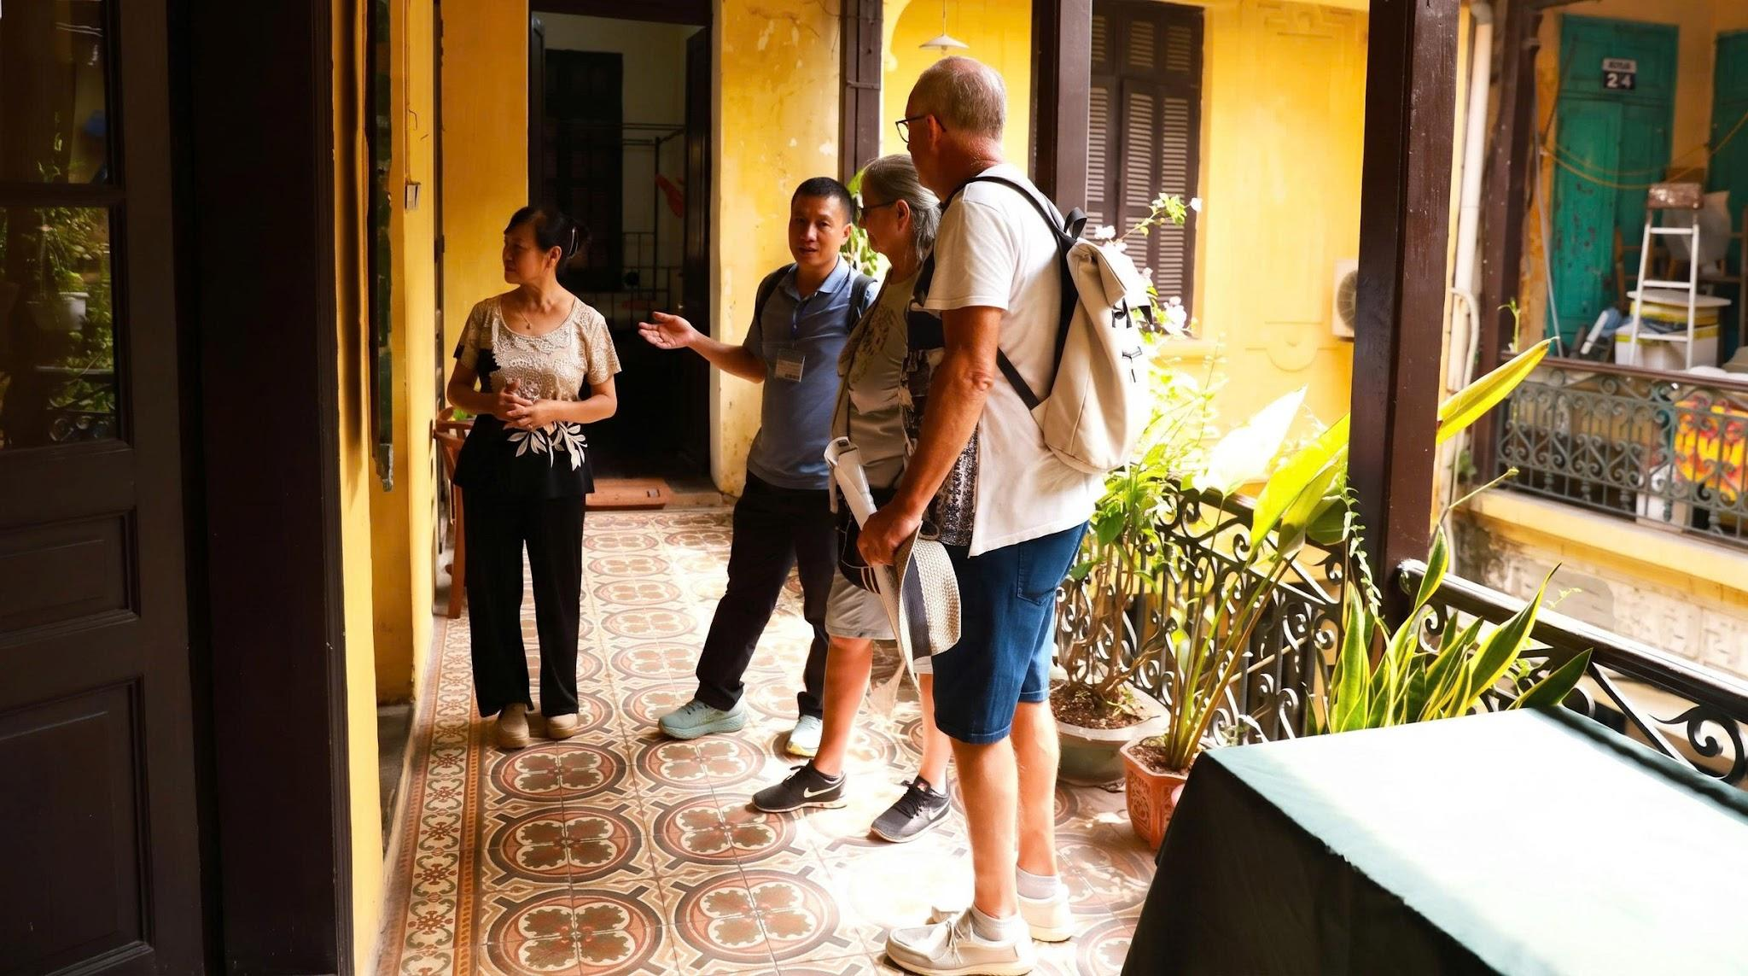
The old villa is now also a sightseeing destination for many foreign tourists.
"I am happy that my home is known to many people. I have never thought about selling or renovating the villa, in the hope that future generations will live here and preserve the values left behind by our ancestors," Thuy adds.
Nga Thanh

